Applied Calculus Sample Technology Problem 02

Solve each problem using technology. http://www.wolframalpha.com

- Find an expression for the instantaneous rate-of-change of the function. $f\left(x\right)=x^{2}-5x+2$

$2x-5$

- Find the instantaneous rate-of-change of the function
$f\left(x\right)=6x^{4}- x^{3}+4x^{2}+8x-11$
at $x=2$. Interpret your value in terms of input and output.

$204$

Interpretation: If the input value increases by 1 unit, from 2 to 3, the output value will increase by approximately 204 units.

Do all these things:

- Go to the WolframAlpha site: http://www.wolframalpha.com
- In the entry field use the “derivative” command to get W|A find the instantaneous rate-of-change of the function.

- Circle your answer on the W|A page and enter it in the box at the problem.

Problem 01
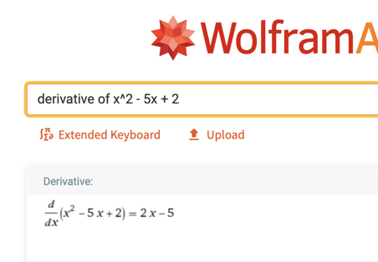

Problem 02
