Applied Calculus Sample Technology Problem 03

Solve each problem using technology. http://www.wolframalpha.com

- Find an expression for $f'\left(x\right)$ for the function
$f\left(x\right)=\frac{{\left(2x+3\right)}^{4}}{{\left(3x+2\right)}^{5}}$

- Find an expression for $f'\left(0\right)$ for the function
$f\left(x\right)={\left(2x+3\right)}^{4}{\left(3x+2\right)}^{5}$

- Complete the sentence: For $f\left(x\right)=\frac{x^{2}-5x+1}{x^{2}-2x-3}$, if $x$increases by 1 unit from 4 to 5, we expect $f\left(x\right)$ to

Round your answer to 2 decimal places.

Do all these things:

- Go to the WolframAlpha site: http://www.wolframalpha.com
- In the entry field use the “derivative” command to get W|A find the instantaneous rate-of-change of the function.

- Circle your answer on the W|A page and enter it in the box at the problem.

Problem 01
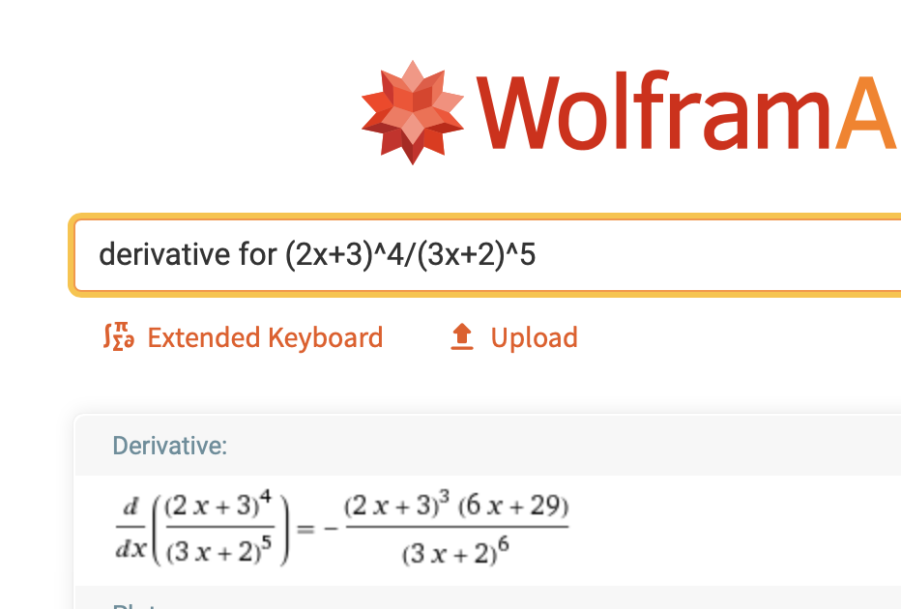

Problem 02
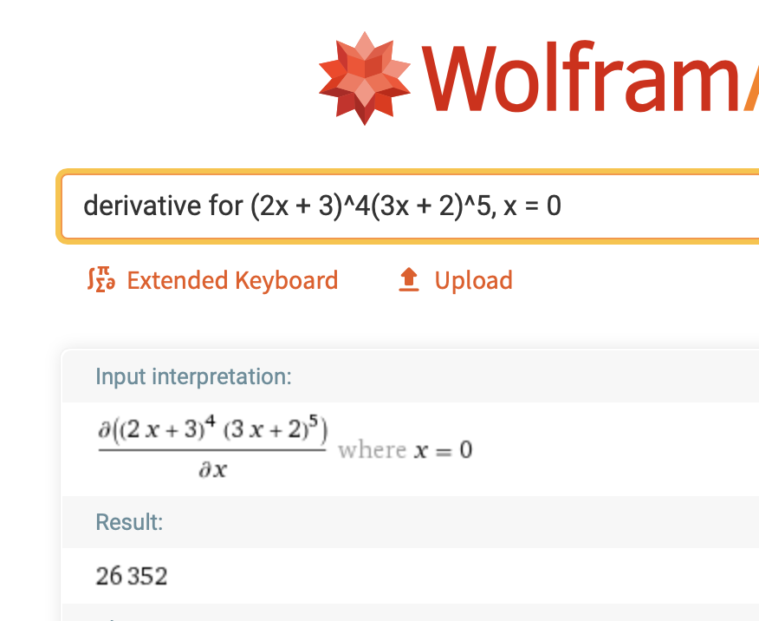

Problem 03
Click on the fraction 33/25 to automatically convert it to decimal number. 1.32.

Round to two decimal places.
1.32

if $x$increases by 1 unit from 4 to 5, we expect $f\left(x\right)$ to
increase by about 1.32 units.

