Applied Calculus Sample Technology Problem 04

Solve each problem using technology. http://www.wolframalpha.com

- Compute both the first and second derivatives for the function
$f\left(x\right)=\frac{\sqrt{x^{2}-1}}{{\left(x^{2}+1\right)}^{2}}$ at $x=2$

$$f^{'}\left(2\right)=-\frac{14}{125\sqrt{3}}$$

$$f^{''}\left(2\right)=\frac{179}{1875\sqrt{3}}$$

Use the information from the signs of $f^{'} \text{and }f''$ to comment on the behavior of $f\left(x\right)$ at $x=2$
Since $f^{'}\left(2\right)<0 \text{and }f^{''}(2)>0, \text{we note that a}$t $x=2,$ $f\left(x\right)$ is decreasing at a decreasing rate.

Do all these things:

- Go to the WolframAlpha site: http://www.wolframalpha.com
- In the entry field use the “d/dx” and the “d^2/dx^2” commands to get W|A find the the first and second derivatives.

- Circle your answer on the W|A page and enter it in the box at the problem.

Problem 01

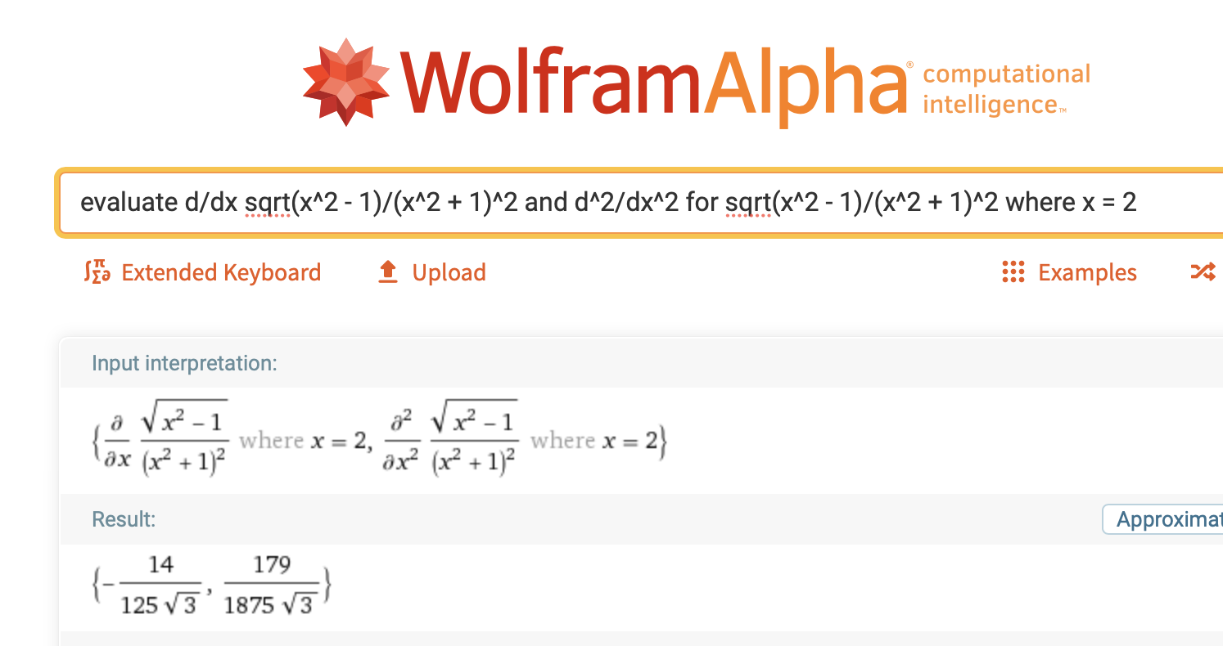

Negative
Positive

(–)(+) = (–) so decreasing at a decreasing rate.

negative so the function is decreasing

Reminds us of “decreasing”

