Applied Calculus Sample Technology Problem 05

Solve each problem using technology. http://www.wolframalpha.com.

Do all these things:
- Go to the WolframAlpha site: http://www.wolframalpha.com
- In the entry field use the “dy/dx” command to get W|A to implicitly differentiate the function.

- Circle your answer on the W|A page and enter it in the box at the problem.

- Use WolframAlpha to help you find $\frac{dy}{dx}$, that is, $y'$, for the implicitly defined function

$$3x^{3}y^{6}-2x=x^{5}+3y$$

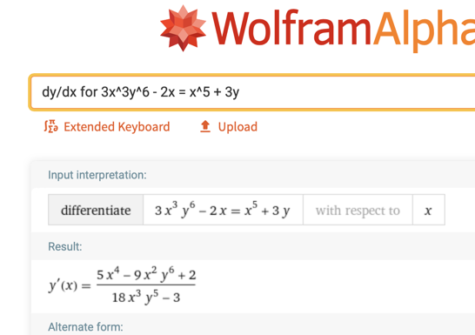

- Use WolframAlpha to help you find the slope of the tangent line to the curve
$x^{3}+y^{4}=9$ at the point $(-4,\sqrt[4]{73)}$. Interpret this slope in terms of changes in $x$ and $y$. Round your value to 2 decimal places.
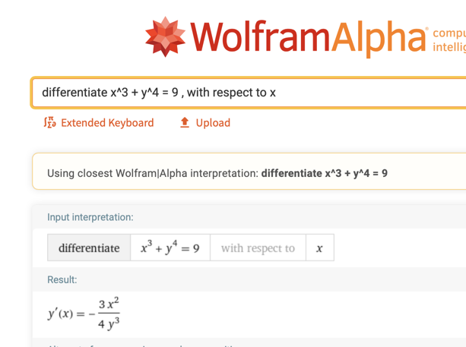

First: Get the derivative $dy/dx$

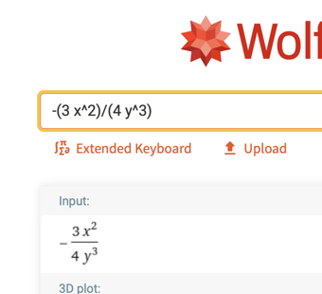

Second: Click on $-\frac{x^{3}}{y^{3}}$ to get it ready for evaluation.

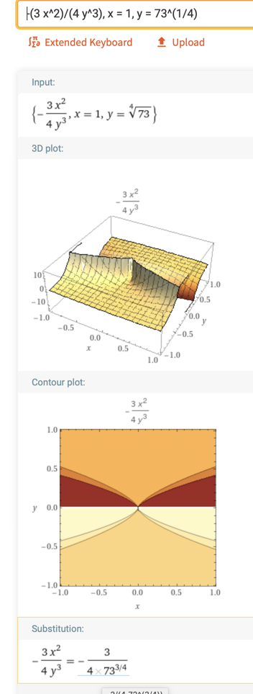

Third: In the entry field type

Fourth: Click on the fraction to convert it to a decimal.

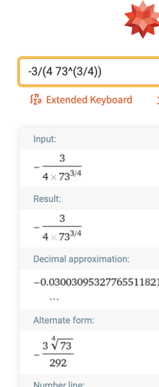

Fifth: Round to two decimal places. $-0.03$

If $x$ increases by 1 unit, from 1 to 2, $y$ will decrease by approximately 0.03 units.

