Applied Calculus Sample Technology Problem 05

Solve each problem using technology. http://www.wolframalpha.com
2 problems at 4 points each 8 points
No late papers will be accepted If you think you might not be able to hand the assignment in on the due date, hand it in early.

Do all these things:
- Go to the WolframAlpha site: http://www.wolframalpha.com
- In the entry field use the “dy/dx” command to get W|A to implicitly differentiate the function.

- Circle your answer on the W|A page and enter it in the box at the problem.

- Use WolframAlpha to help you find $\frac{dy}{dx}$, that is, $y'$, for the implicitly defined function

$$4x^{2}y^{7}-2x=x^{5}+4y$$

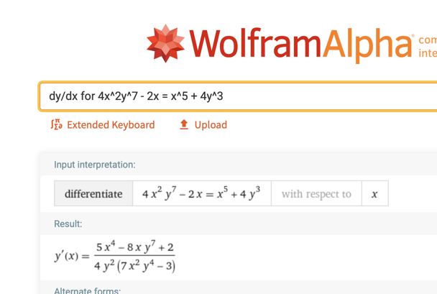

- Use WolframAlpha to help you find the slope of the tangent line to the curve
$x^{4}+y^{4}=16$ at the point $(1,\sqrt[4]{15)}$. Interpret this slope in terms of changes in $x$ and $y$.

The solution to this problem involves several steps.

First: Get the derivative $dy/dx$
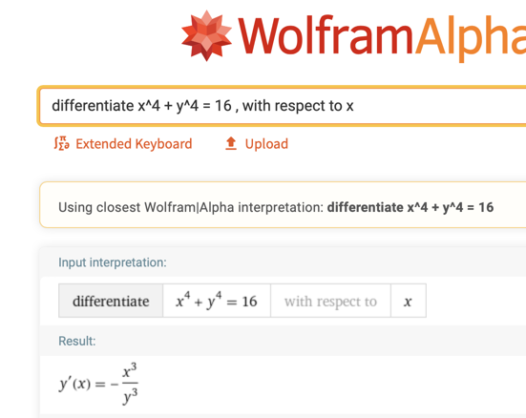

Second: Click on $-\frac{x^{3}}{y^{3}}$ to get it ready for evaluation.
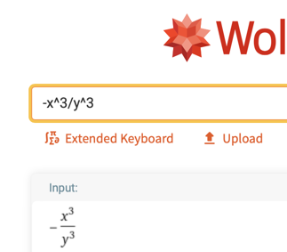

Third: In the entry field type

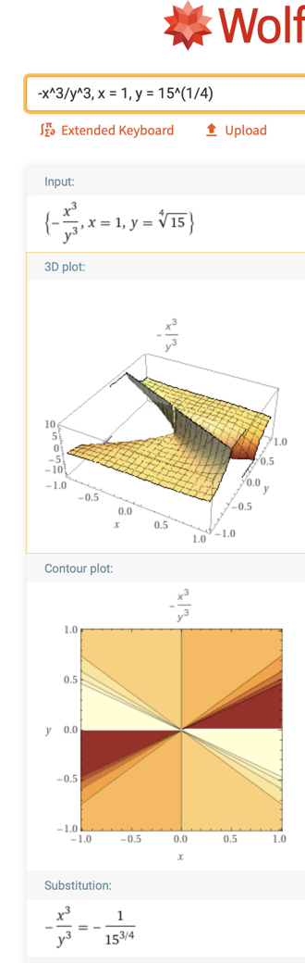

Fourth: Click on the fraction to convert it to a decimal.

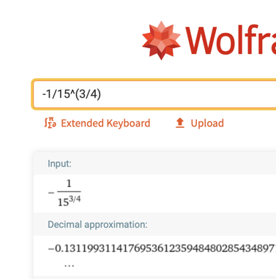

Fifth: Round to two decimal places. $-0.13$

If $x$ increases by 1 unit, from 1 to 2, $y$ will decrease by approximately 0.13 units.

