Applied Calculus Technology Problem 05 Solutions

Solve each problem using technology. http://www.wolframalpha.com

- Use WolframAlpha to help you find $\frac{dy}{dx}$, that is, $y'$, for the implicitly defined function

$$4x^{2}y^{7}-2x=x^{5}+4y$$

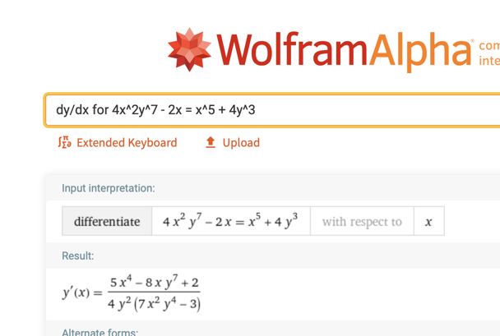

- Use WolframAlpha to help you find the slope of the tangent line to the curve
$x^{4}+y^{4}=16$ at the point $(1,\sqrt[4]{15)}$. Interpret this slope in terms of changes in $x$ and $y$.

The solution to this problem involves several steps.

First: Get the derivative $dy/dx$

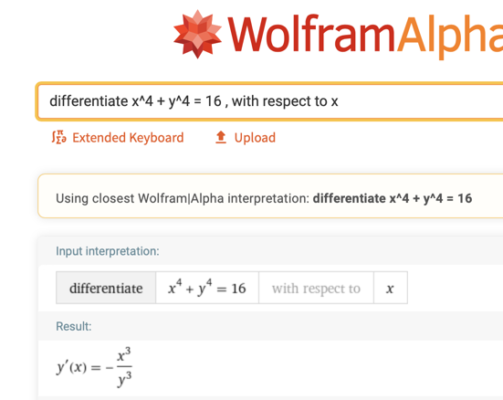

Second: Click on $-\frac{x^{3}}{y^{3}}$ to get it ready for evaluation.
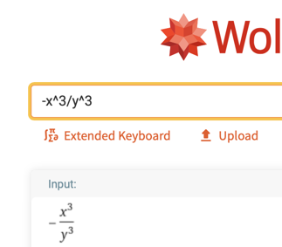

Third: In the entry field type

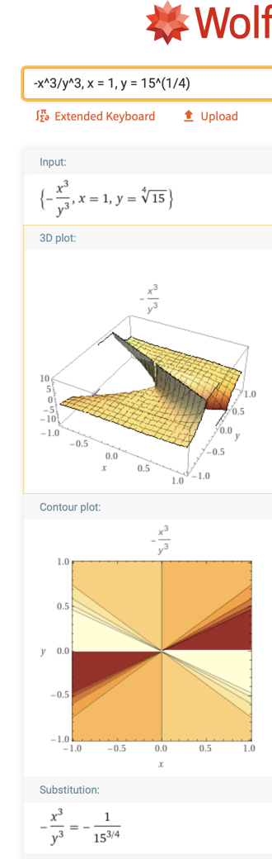

Fourth: Click on the fraction to convert it to a decimal.

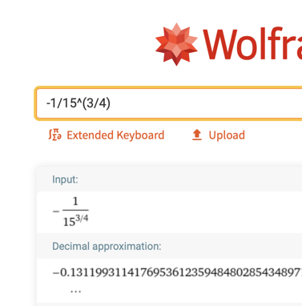

Fifth: Round to two decimal places. $-0.13$

If $x$ increases by 1 unit, from 1 to 2, $y$ will decrease by approximately 0.13 units.

