Applied Calculus Sample Technology Problem 08

Solve each problem using technology. http://www.wolframalpha.com

A company anticipates selling 3200 units of its product at a uniform rate over the next year. Each time the company places an order for $x$ number of units, it is charged a flat fee of $50. Carrying costs are $32 per unit per year.
- Write the inventory cost function that is to be minimized.
- How many times should the company reorder each year to minimize its inventory cost?
- What should be the lot size of each reorder to minimize its inventory cost?
- What is the minimum inventory cost?

This problem is Example 5 on page 279 in Section 3.4 of our textbook. To answer question1, read through it to see how to develop the inventory cost function $C\left(x\right).$

Once you have the inventory cost function $C\left(x\right),$ use WolframAlpha to minimize it.

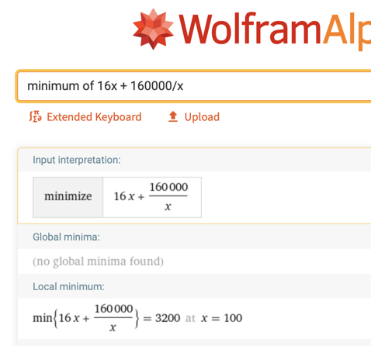

- The inventory cost function is

$C\left(x\right)=$16x + $\frac{160,000}{x}$

W|A gives you the answers to questions 3 and 4.

3. The lot size that will minimize inventory cost is 100.
4. The minimum inventory cost is $3200.

To answer question 2, note that if the company anticipates selling 3200 units with a lot size of 100, then the numbers of order each year is 3200/100 = 32. Now you can answer question 2.

- To minimize its inventory cost this year, the company should make 32 reorders.

