Applied Calculus Sample Technology Problem 09

Solve each problem using technology. http://www.wolframalpha.com

We use mathematics to study relationships between two quantities. To do so, we collect data as ordered pairs and plot them to form a scatter diagram (a graph). We carefully observe the scatter diagram to see if a trend exists. If the data points seem to collect along a curve of some kind, we might think the two quantities are correlated. That is, we might think the quantities are associated closely enough that if we know the value of one, we can predict (approximate) the value of the other. If the scatter diagram shows the data points appear to lie along a straight line, we say there is a linear correlation between the two quantities. If the scatter diagram shows the data points appear to lie along a particular type of curve, we say there is some other type of correlation between the variables. That relationship might be quadratic or cubic or exponential. Statistical methods can then be used to construct an equation of a line-of-best-fit or curve-of-best-fit, that is, a line or a curve that is as close to each data point as possible. This activity is called regression analysis.

The weekly number of digital media and wireless internet users in the U.S. has increased dramatically since the beginning of 2005. The table displays the number of users for each year from 2005 through 2010. (Source: Bridge Ratings) The number of users is in the millions.
Year | 2005 | 2006 | 2007 | 2008 | 2009 | 2010
Number | 5.7 | 10.1 | 19.2 | 28.8 | 51.8 | 93.3

  - (Regression analysis) Use the exponential fit command to find the exponential expression that best fits the data.
Let t be the number of years from the 2005. Then 2005 0, 2006 1, 2007 2, 2008 3, 2009 4, and 2010 5

$5.53594e^{0.563773x}$

  - (Evaluation) Use the evaluate command to estimate the number of wireless internet users in June, 2008. Round to the nearest whole number.
$$40$$

  - (Equation solving) Use the solve command to estimate in what year were there approximately 25 million wireless internet users. Round to the nearest whole number.

$2008$

  - (Calculus) At what rate is the number of wireless internet users increasing/decreasing in the year 2010?

Increasing at the rate of 52.3 million users per year.

Part a)

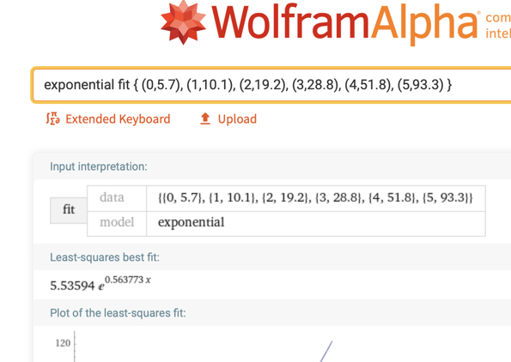

Part b) June 2008 is year 3 from 2005 and 1/2-way through June so use x = 3.5

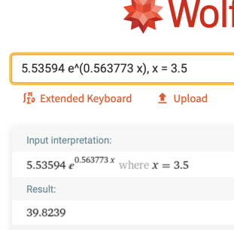

Part c)



$x=3$ but remember $x$ is the number of years from the beginning of 2005. So, 2005 + 3 puts us at 2008

Part d)
The year 2010 is 5 years from 2005 so at $x=3$, the number of wireless internet users increasing at the rate of 52.3 million users per year.
