Applied Calculus Technology Problem 09 Solutions

4 Problems: 8 Points

Solve each problem using technology. http://www.wolframalpha.com

For the drug Valium, there is a relationship between the number of hours t since the drug entered the bloodstream and the number A of milligrams of the drug that remain in the bloodstream. The table shows how the amount of valium changes as time since a 10-milligram tablet of valium was taken by an adult male.

Time, t in hours | 0 | 1 | 6 | 12 | 18 | 24 | 36 | 48
Number of mg of Valium in the bloodstream, A | 10 | 9.5 | 7.0 | 5.0 | 3.5 | 2.5 | 1.2 | 0.6

  - (Regression analysis) Find the exponential expression that best fits the data.

  - (Evaluation) Estimate the number of milligrams of valium in the bloodstream 15 hours after a 10-millgram tablet was taken.

About 4.2 mg.

  - (Equation solving) About how many hours after a person takes a 10-mg table of valium will there be about 4 mg in the bloodstream?

About 16 hours.

decreasing at 0.46 mg/per hour.
  - (Calculus) At what rate is the number of mg increasing/decreasing 4 hours after taking the 10-mg table of valium?

Problem a)
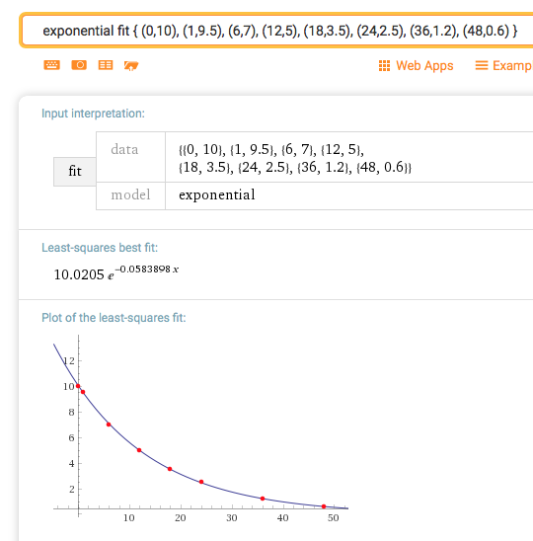

Problem b)
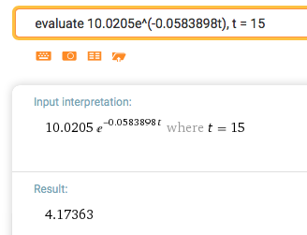

Problem c)
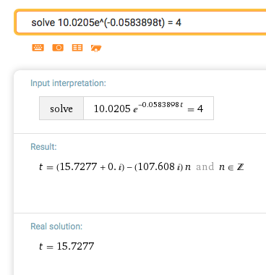

Problem d)
The number of mg of valium at 4 hours is decreasing at 0.46 mg/per hour.

