Applied Calculus Sample Technology Problem 10

Solve each problem using technology. http://www.wolframalpha.com

This is Exercise 53, page 365 from section 4.4 in our textbook.
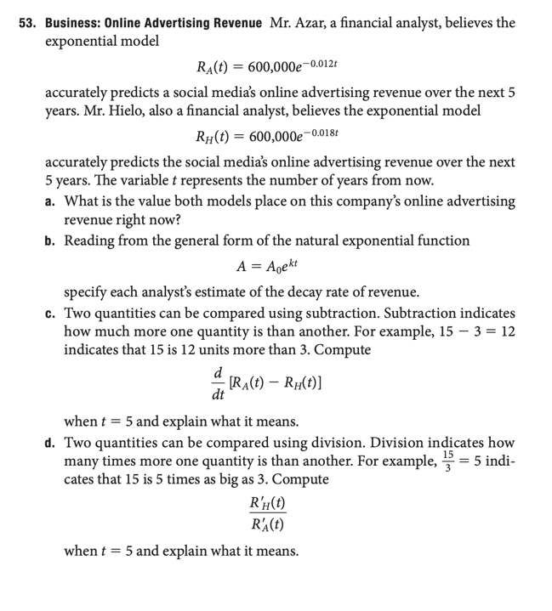

Part a)

Right now, $t=0$ so that

For Mr A
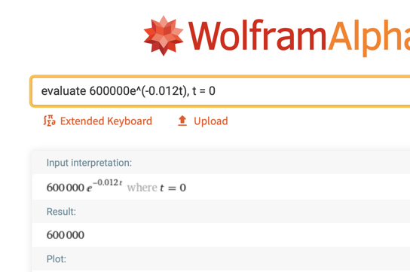

For Mr B

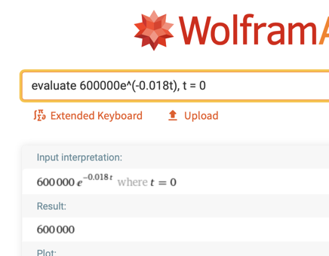

Both models compute to
$600,000, so both Mr A and Mr H value the company right now at $600,000.

You could answer this question without making any computations by noting the start value in the model is 600,000. This comes from the general form for the exponential function $A=A_{0}∙b^{kx}$, where $A_{0}$ is the start value, 600,000 in our case.

Part b) In the general exponential function, $=A_{0}∙b^{kx}$, $k$ represents the growth (decay) rate.

Reading from each analyst’s model,

Mr A: $A=600,000∙e^{-0.012t}$ -0.012 = 1.2%

Mr H: $A=600,000∙e^{-0.018t}$ -0.018 = 1.8%

Decay rate for Mr A is 1.2% per year, and the

Decay rate for Mr H is 1.8% per year.

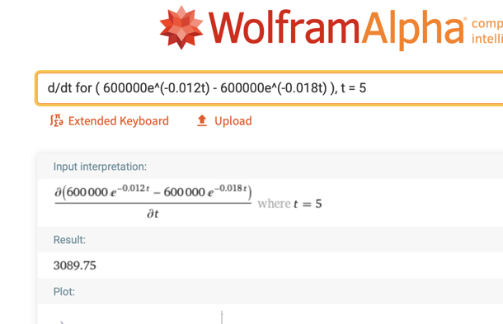

Part c)

If the number of years from now increases by 1, from 5 to 6, Mr. Azar’s estimate of the company’s revenue will be about $3089.75 higher than Mr. Hielo’s estimate.

Notice that Mr. Hielo’s estimate is in the numerator and that Mr. Azar’s estimate is in the denominator. This quotient will tell us how many times bigger the top number is than the bottom number.
Part d)

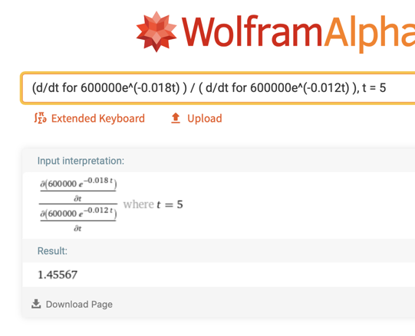
Five years from now, the rate at which Mr. Hielo believes revenue will be decreasing will be about 1.46 times the rate at which Mr. Azar believes the revenue will be decreasing.

