Applied Calculus Technology Problem 10

Use http://www.wolframalpha.com technology to help you solve this problem.

This is Exercise 52 on page 364 in section 4.4 from our textbook.
1 problem at 4 parts and 1 point per part 4 points

This problem is due by *****.

Model your work for this problem from the Sample Tech Problem. Just change the functions and write the interpretations using the sample as a guide. Be sure your wording in your answer matches the wording in this problem. This problem closely matches the sample, don’t make it harder than it is.
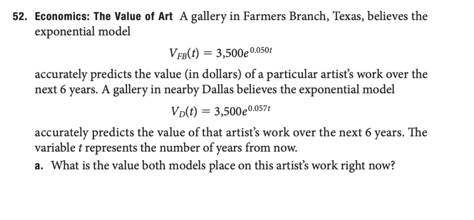
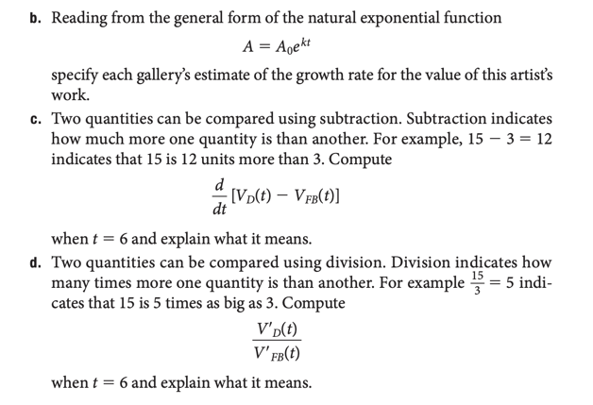

Six years from now, the rate at which the Dallas gallery believes the revenue will be increasing will be about 1.19 times the rate at which the FB gallery believes the revenue will be decreasing.

