Math 124 Technology Problem 10 Solutions

Solve each problem using technology. http://www.wolframalpha.com

This is Exercise 52 from our textbook.

Model your work for this problem from the Sample Tech Problem. Just change the functions and write the interpretations suing the sample as a guide. Be sure your wording in your answer matches the wording in this problem.
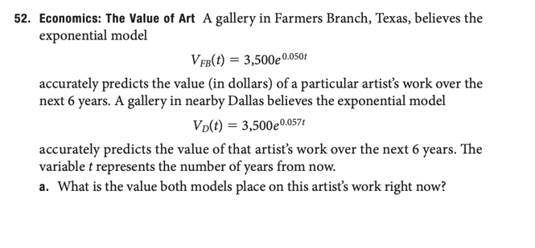
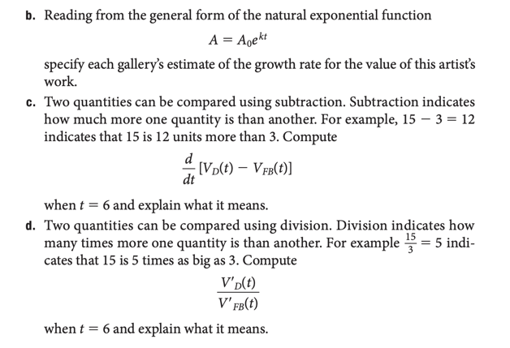

Part a)

Right now, $t=0$ so that

For Farmer’s Banch,
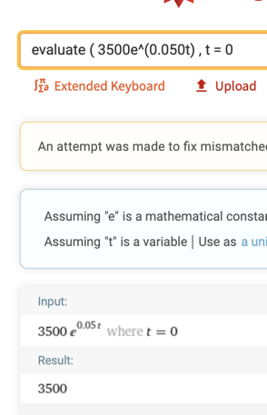

For Dallas,
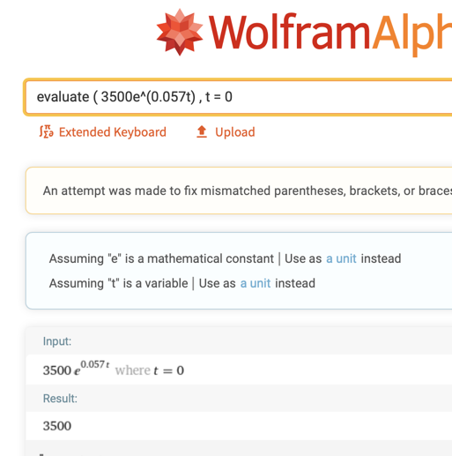

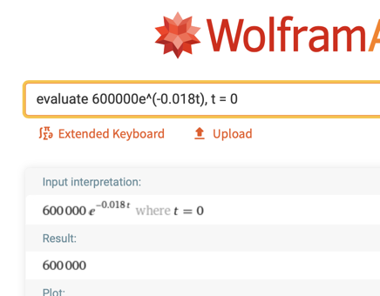

Both models compute to
$3500, so both galleries value the artist’s work now at $3500.

You could answer this question without making any computations by noting the start-value in the model is 3500. This comes from the general form for the exponential function $A=A_{0}∙b^{kx}$, where $A_{0}$ is the start value, 3500 in our case.

Part b) In the general exponential function, $=A_{0}∙b^{kx}$, $k$ represents the growth rate.

Reading from each analyst’s model,

Farmer’s Branch: $A=3500∙e^{0.050t}$ 0.050 = 5.0%

Dallas Gallery: $A=3500∙e^{0.057t}$ 0.057 = 5.7%

Growth rate for FB gallery is 5.0% per year, and the

Growth rate for the Dallas gallery is 5.7% per year.

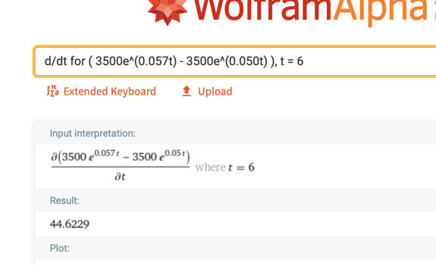

Part c)

If the number of years from now increases by 1, from 6 to 7, The Dallas gallery’s estimate of the company’s revenue will be about $44.62 higher than the Farmer’s Branch gallery’s estimate.

Notice that Dallas gallery’s estimate is in the numerator and that the FB gallery’s estimate is in the denominator. This quotient will tell us how many times bigger the top number is than the bottom number.

Part d)

Six years from now, the rate at which the Dallas gallery believes the revenue will be increasing will be about 1.19 times the rate at which the FB gallery believes the revenue will be decreasing.
