Applied Calculus Technology Problem 11 Solutions

Solve each problem using technology. http://www.wolframalpha.com

- Evaluate $\int{(\frac{9}{8}}x^{1/8}+\frac{11}{8}x^{8/11})dx$

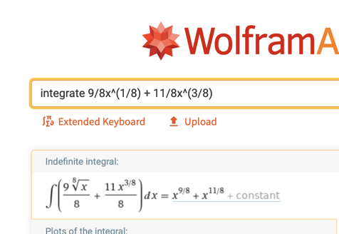

$x^{9/8}+x^{11/8}+C$

- Evaluate $\int{\frac{3x}{\sqrt{2+3x}}}dx$

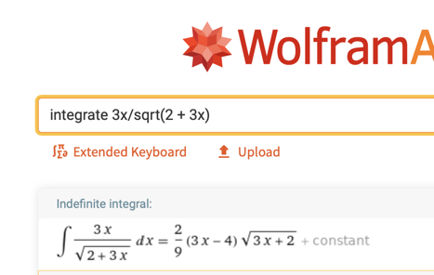

$\frac{2}{9}\left(3x-4\right)\sqrt{3x+2}+C$

- Evaluate $\int{\frac{3θ}{\sqrt{θ^{2}+θ^{3}}}dθ}$
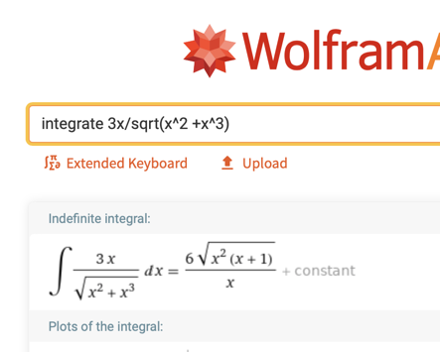

$\frac{6\sqrt{θ^{2}\left(θ+1\right)}}{θ}+C$

The integrand involves the variable $θ$ but $x$ is easier to type into W|A. The answer comes out in $x$ but you must convert it back to the original variable $θ$.

- In the manufacture of printing ink, solvents are used to suspend or dissolve the pigments that give ink its color. Suppose that during its manufacture, a process moves its solvent into a vat containing pigments, not at a constant rate, but rather at a rate modeled by the function

$R\left(t\right)=\frac{10t}{\sqrt{4t^{2}+3}}$

liters per minutes, where $t$ is the number of minutes since the start of the process. How many liters of solvent flow into the vat in the first 60 minutes of the process? Round your answer to two decimal places.

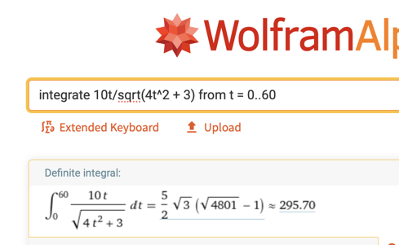



$295.70 L$

