Applied Calculus Sample Technology Problem 12

Solve each problem using technology. http://www.wolframalpha.com

- Evaluate $\int_{2}^{5 }{\left[\left(x-2\right)e^{x^{2}-4x}\right]}dx$. Round your result to 3 decimal places.

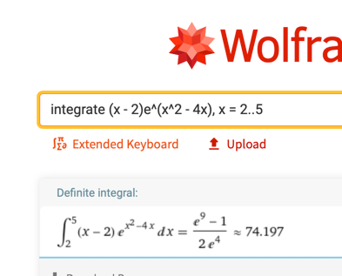

74.197

- Find the area of the shaded green region between the upper curve $y=4- x^{2}$, and the lower curve $y=x^{2}-2x$. Round to 4 decimal places.
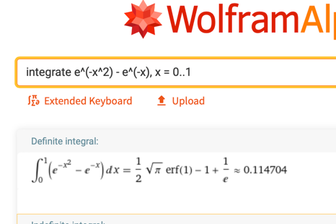
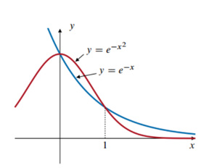

0.1147 square units

- The rate $I$ (in dollars per year) at which incmoe from a rental property flows into an account in which interest is compounded continuosly at 8% is given by the function

$I\left(t\right)=200,000e^{-0.08t}$

where $t$ is the time in years from now. If the income is not disrupted and continues indefinitely, how much money will accumulate in this account? Round your answer to two decimal places.

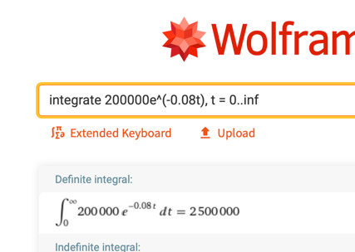

$$\$2,500,000$$

Use inf for infinity

- The capital value of an asset is the annual rate at which earnings are produced by an asset at time $t$. It is defined as the improper integral

$$Capital Value= \int_{0}^{∞}{f\left(t\right)e^{-rt}dt}$$

Where the function $f\left(t\right)$ models the annual rate of a continuous flow in income and $r$ is the annual interest rate, compounded continuously. Suppose that the function
$f\left(t\right)=20,000e^{0.045t}$ models the continuous flow of income produced by a business at time $t$. If money can be invested at 14% compounded continuously, find the capital value of the business.

$$\$210,526$$
