Math 176 Technology Problem 12 Solutions

4 Problems at 2 Points each: 8 Points

This problem is due on Thursday, April 29. No late papers! You can always hand in this assignment early, just not late.

Solve each problem using technology. http://www.wolframalpha.com

- Evaluate $\int_{0}^{1 }{\left[2e^{-x}+x-\frac{1}{2}e^{x}\right]}dx$. Round your result to 4 decimal places.
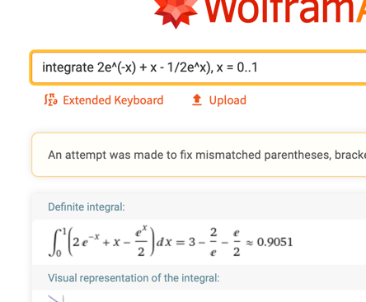

$$0.9051$$

- Find the area of the shaded green region between the upper curve $y=4- x^{2}$, and the lower curve $y=x^{2}-2x$.
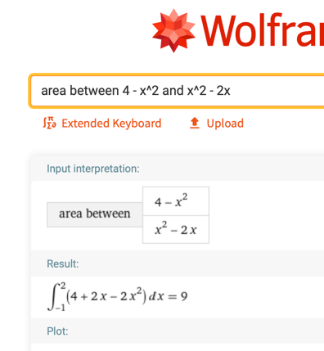
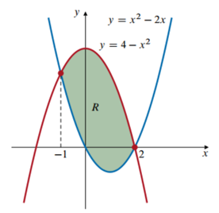

9 square units

- The capital value of an asset is the annual rate at which earnings are produced by an asset at time $t$. It is defined as the improper integral

$$Capital Value= \int_{0}^{∞}{f\left(t\right)e^{-rt}dt}$$

Where the function $f\left(t\right)$ models the annual rate of a continuous flow in income and $r$ is the annual interest rate, compounded continuously. Suppose that the function
$f\left(t\right)=12,000e^{0.05t}$ models the continuous flow of income produced by a business at time $t$. If money can be invested at 10% compounded continuously, find the capital value of the business.
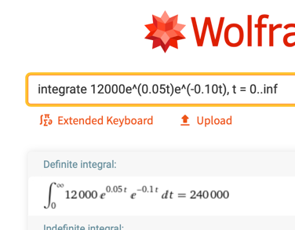

$240,000

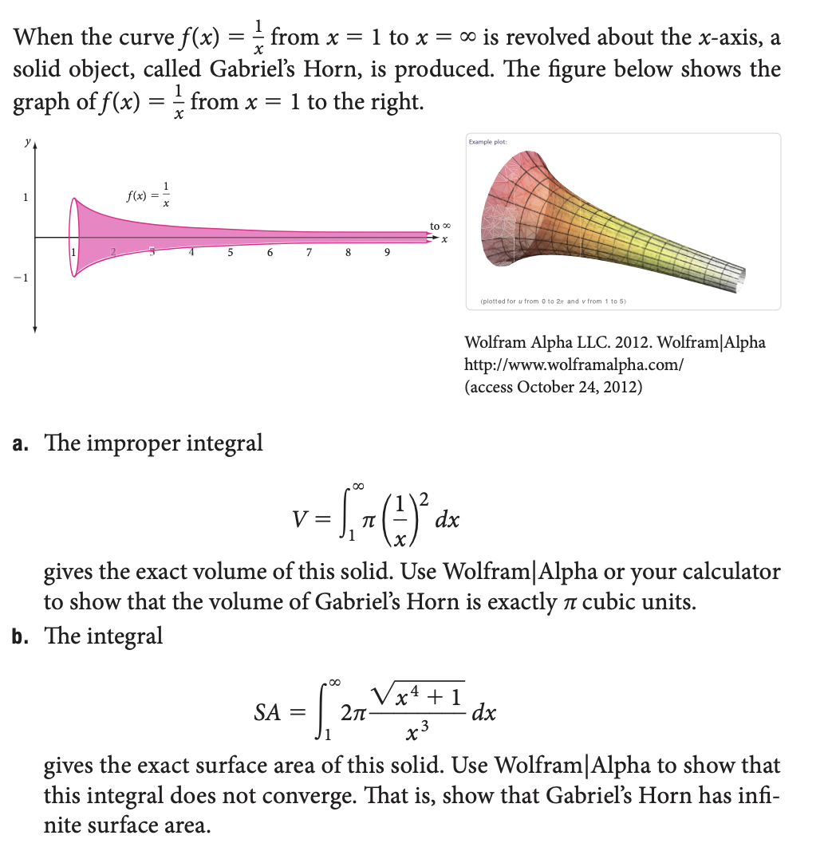

- Use the improper integral $V=\int_{1}^{∞}{π{\left(\frac{1}{x}\right)}^{2}}dx$ to find the exact volume of this solid. Don’t round your answer, but rather provide the exact volume.

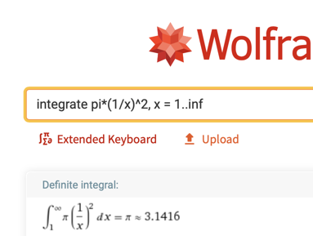

This is the exact value

$π$ cubic units

- Use the Evaluate the improper integral $SA=\int_{1}^{∞}{2π\frac{\sqrt{x^{4}+1}}{x^{3}}}dx$
to demonstrate that Gabriel’s Horn has infinite surface area.

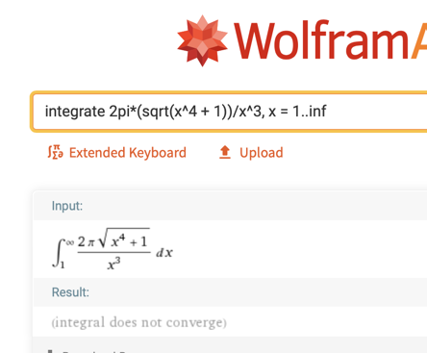

This integral does not converge. That is, the surface area is infinite.

