Applied Calculus Technology Problem 12

4 Problems at 2 Points each: 8 Points

This problem is due on *****. No late papers! You can always hand in this assignment early, just not late.

Solve each problem using technology. http://www.wolframalpha.com

- Evaluate $\int_{0}^{1 }{\left[2e^{-x}+x-\frac{1}{2}e^{x}\right]}dx$. Round your result to 4 decimal places.

- Find the area of the shaded green region between the upper curve $y=4- x^{2}$, and the lower curve $y=x^{2}-2x$.
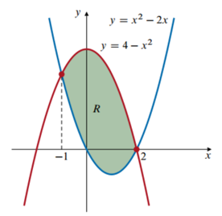

- The capital value of an asset is the annual rate at which earnings are produced by an asset at time $t$. It is defined as the improper integral

$$Capital Value= \int_{0}^{∞}{f\left(t\right)e^{-rt}dt}$$

Where the function $f\left(t\right)$ models the annual rate of a continuous flow in income and $r$ is the annual interest rate, compounded continuously. Suppose that the function
$f\left(t\right)=12,000e^{0.05t}$ models the continuous flow of income produced by a business at time $t$. If money can be invested at 10% compounded continuously, find the capital value of the business.

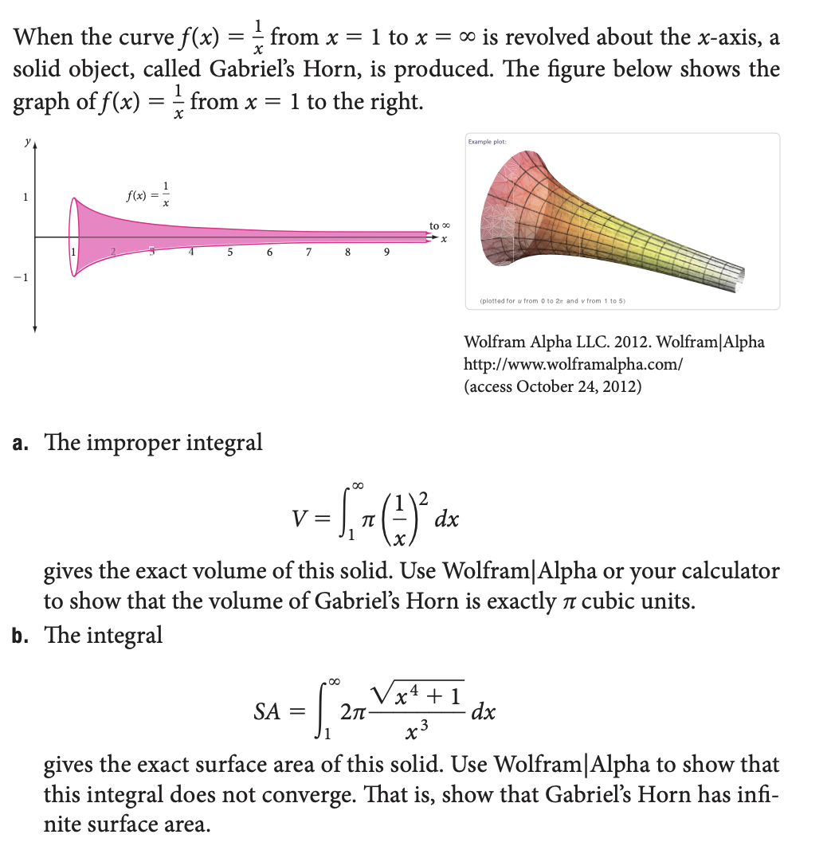

- Use the improper integral $V=\int_{1}^{∞}{π{\left(\frac{1}{x}\right)}^{2}}dx$ to find the exact volume of this solid. Don’t round your answer, but rather provide the exact volume.

- Use the Evaluate the improper integral $SA=\int_{1}^{∞}{2π\frac{\sqrt{x^{4}+1}}{x^{3}}}dx$
to demonstrate that Gabriel’s Horn has infinite surface area.

The amazing thing you are witnessing and proving here is that Gabriel’s Horn is an object that has finite volume, but infinite surface area. That is, Gabriel’s Horn is an object that you could fill up with paint, but not ever have enough paint to paint its surface.

Do all these things:
- Go to the WolframAlpha site: http://www.wolframalpha.com
- In the entry field use the “integrate command to get W|A to evaluate each integral

- Circle your answer on the W|A page and enter it in the box at the problem.

