Applied Calculus Sample Technology Problem 13

Solve each problem using technology. http://www.wolframalpha.com

You can find a sample problem on page 485 of our textbook on page. See Example 3. You will use the “solve” command to solve an equation, then the “integrate” command twice to evaluate two integrals.
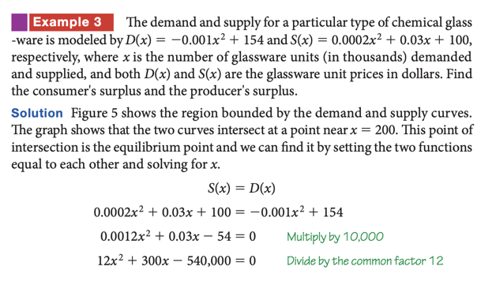

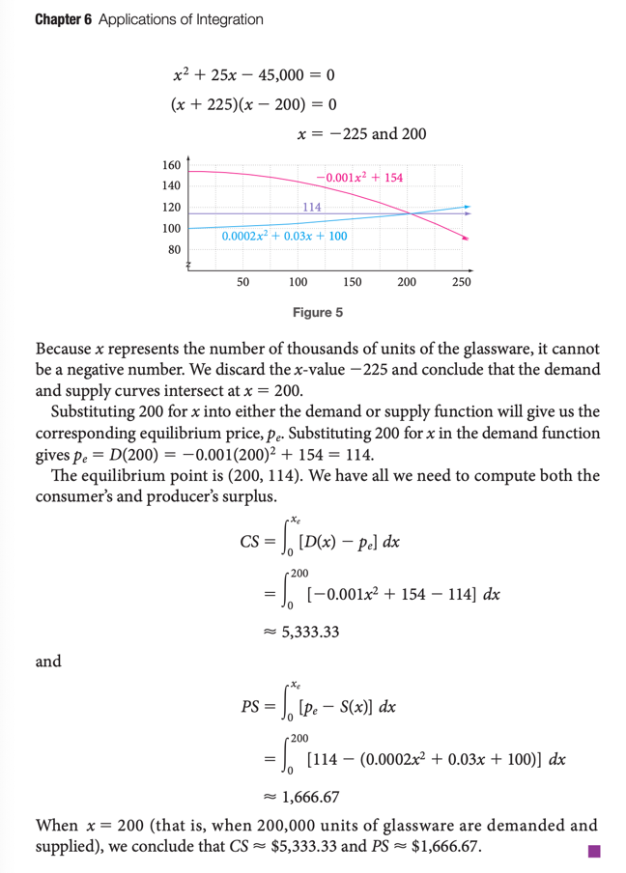

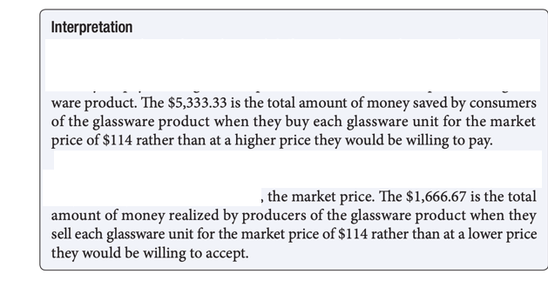

- Find the equilibrium point,$\left(x_{e}, p_{e} \right)$.
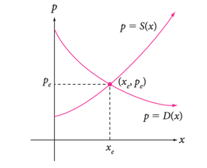
The equilibrium point, $\left(x_{e}, p_{e} \right),$ is the point at which supply equals demand, and can be found by solving the equation $D\left(x\right)=S\left(x\right)$, then using the value of $x$ to get the value of $p$. It is illustrated in the picture.

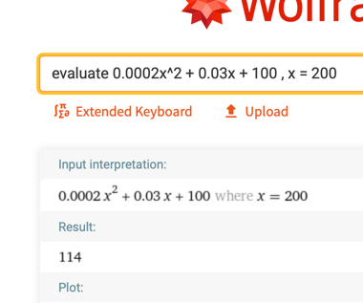

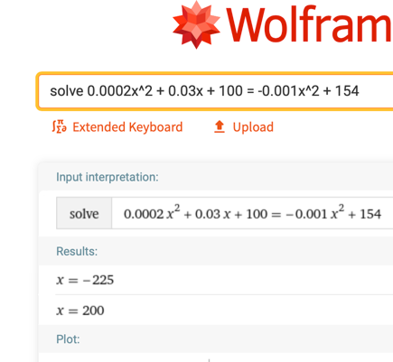

$$\left(x_{e}, p_{e} \right)=(200, 114)$$

- Find the consumer’s surplus using $CS= \int_{0}^{x_{e}}{\left[D\left(x\right)- p_{e}\right]dx}$
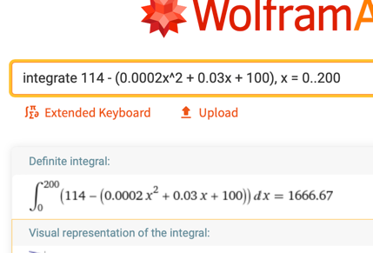

$$CS=\$1666.67$$

- Find the producer’s surplus using $PS= \int_{0}^{x_{e}}{\left[ p_{e }-S(x)\right]dx}$.
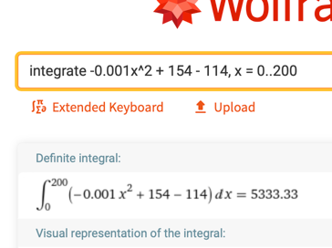

$$PS=\$5333.33$$

- Explain what the consumer’s surplus means.

The $1666.67 is the amount of money saved by consumers of the glassware product when they buy each unit for $114 rather than at a higher price they were willing to pay.

- Explain what the producer’s surplus means.

The $5333.33 is the total amount of money realized by producers of the glassware product when they sell each unit for $114 rather than at a lower price that they were willing to accept.

