Applied Calculus Technology Problem 13

5 Problems at 2 Points each: 10 Points

This problem is due on *****. No late papers! You can always hand in this assignment early, just not late.

Solve each problem using technology. http://www.wolframalpha.com

You can find a sample problem on page 484 of our textbook on page. See Example 2. You will use the “solve” command to solve an equation, then the “integrate” command twice to evaluate two integrals.

The monthly demand for a particular type of glass is related to the price of the item by the function $D\left(x\right)=-0.01x^{2}+220,$ where the price is in dollars and $x$ is in thousands of units. A manufacturer will supply $x$ thousands of units when the price of the item is
$S\left(x\right)=0.03x^{2}-1.6x+136$ dollars.

- Find the equilibrium point,$\left(x_{e}, p_{e} \right)$.
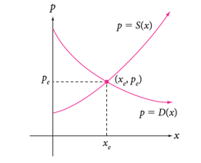
The equilibrium point, $\left(x_{e}, p_{e} \right),$ is the point at which supply equals demand, and can be found by solving the equation $D\left(x\right)=S\left(x\right)$, then using the value of $x$ to get the value of $p$. It is illustrated in the picture.

- Find the consumer’s surplus using
$CS= \int_{0}^{x_{e}}{\left[D\left(x\right)- p_{e}\right]dx}$

- Find the consumer’s surplus using $PS= \int_{0}^{x_{e}}{\left[ p_{e }-S(x)\right]dx}$.

- Explain what this consumer’s surplus means.

- Explain what this producer’s surplus means.

Do all these things:
- Go to the WolframAlpha site: http://www.wolframalpha.com
- Use the “evaluate” and “integrate” command to get W|A to find the values you are looking for.

- Circle your answer on the W|A page and enter it in the box at the problem.

