Applied calculus Technology Problem 14 Solutions
3 Problem, 9 Points

Solve each problem using technology. http://www.wolframalpha.com

The future value of such an income stream is given by the integral

$FV= e^{rT}\int_{0}^{∞}{f\left(t\right)e^{-rt}}dt$ and

the present value by the integral

$PV= \int_{0}^{∞}{f\left(t\right)e^{-rt}}dt$.

A company can buy a machine that it expects will increase the company’s net income by $300,000 each year for the 5-year life of the machine. The company also estimates that for the next 5 years, the money they invest from that continuous stream will earn 7.6% compounded continuously.

- Find the future value of the income stream over the next 5 years.
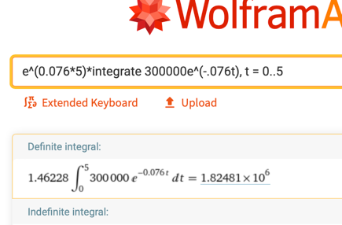

$1,824,810

- Find the present value of the income stream.
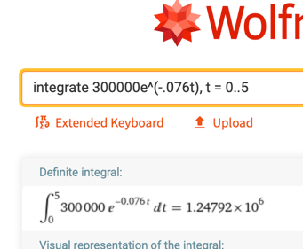

$1,247,920

- Rental income from a piece of property, upon which there is an indefinite lease, flows in continuously at the rate of $85,000 per year. The income in invested immediately into an account paying 6.3% annual interest compounded continuously. How much money would have to be invested right now as a lump sum to match the money that would be realized from the rental income stream?

This is a present value problem so we will use $PV= \int_{0}^{∞}{f\left(t\right)e^{-rt}}dt$

$1,249,210
